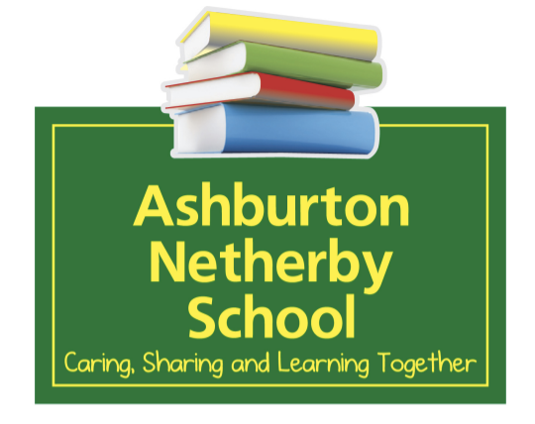

Annual Plan 2025 (analysis of variance)
School Vision:
Quality Teaching, Quality Learning

School Mission Statement:
Aim high, do your best, be resilient, have fun.

School Motto Statement:
Aim high, do your best, be resilient, have fun.

Presiding Board Member: Jenny Doak
Strategic Goals | Board and community reason for prioritising. | Links  to NELPs | Links to Tiriti of Wāitangi | How will we measure success or gather evidence?
Strategic Aim 1:  Continue to build teacher capacity and capability in culturally responsive pedagogy, curriculum design and delivery of teaching and learning. | Aspiring for best practice and modifying teacher’s learning programmes to align with our vision of Quality Teaching, Quality Learning.  This aim is  teacher consulted, as well as being deemed necessary to have space for ongoing improvement. | All aspects of the NELPs are weaved through this strategic goal. The NELPs are captured and implemented in school policy and procedure. | Building teacher capability and capacity in core subject teaching is paramount to keep abreast of evidenced based practice.  Our pedagogy is underpinned by our six Māori metaphors of whanaungatanga, kotahitanga, whakapapa, ako, wāngana, and kaupapa. | Longitudinal data for  Mid and End of Year data collection points, and reporting periods.  Integrated curriculum assessment data.  Teacher’s feedback.  Facilitator of professional development feedback.
Strategic Aim 2:  Continue building teachers’ knowledge in tikanga Māori, Te Ao Māori and te reo Māori. | Te reo Māori is Aotearoa’s first language.  Providing quality Māori language, culture and tikanga experiences align with providing equity for priority learners while honouring aspects of the Tiriti ō Waitangi. | All aspects of the NELPs are weaved through this strategic goal and often the NELPs are captured and implemented in school policy and procedures. | Te reo Māori is Aotearoa’s first language.  Providing quality Māori language, culture and tikanga experiences align with providing equity for priority learners while honouring aspects of the Tiriti ō Waitangi. | Teacher’s progression in and through te reo Māori in the Te Ahu o te reo Māori ki Ngai Tahu.  Senior children achieving at level 2 of the school te reo Māori curriculum.  Integration of cultural ideas from whānau and a Māori lens supporting local curriculum.  Ongoing reasonable steps to provide instruction in both te reo and tikanga Māori
Strategic Aim 3:  Understand, develop and implement our new school curriculum refresh Te Mātaiaho. | Ministry of Education requirement. This will take considerable thought and time and needs to be prioritised as it will be the foundational policy underpinning our Netherby School’s refreshed and developed curriculum. | All aspects of the NELPs are weaved through this strategic goal and often the NELPs are captured and implemented in school policy and procedures. | Links to community input, connection through genuine partnership will align to a curriculum, which values ākonga identity, uniqueness and diversity through valuing language, culture and identity. | A school curriculum written, designed and implemented with its essence being underpinned by the Whakapapa of Te Mātaiaho  A curriculum that reflects tikanga Māori, mātauranga Māori and te ao Māori
Strategic Aim 4:  Focus on working together with the community and agencies in partnership to improve attendance to reach 80% of children attending school 90% of the time when needed. | This is a nationwide call on action to improve attendance across New Zealand with the aim of improving educational outcomes. This will take time and a concerted effort. | All aspects of the NELPs are weaved through this strategic goal and often the NELPs are captured and implemented in school policy and procedures. | A number of our children with poor attendance identify as Māori.  To improve attendance we will need to foster partnerships conducive to improving participation. | The aim is to consistently see 80% of children attending school 90% of the time.

Annual Plan
Strategic Aim 1:0 Continue to build teacher capacity and capability in culturally responsive pedagogy, curriculum design and delivery of teaching and learning.
Focus | Annual actions for meeting strategic objectives | Personnel | Time Frame +  Resourcing
Numicon: | - Seek and apply for school wide professional development in the Numicon resource  - Attend online and in person Numicon courses  - Purchase Numicon resources as required and needed.  - Observe experienced Numicon teachers from external schools  - Blend the DMIC methodology/style with Numicon programme  - Review long term plans to follow the Numicon delivery and assessment recommendations  - Use Numicon resources and methodologies to build agreed knowledge at each year group.  - Continue to design school wide assessments that link DMIC and Numicon if possible  - Build Numicon development into schoolwide annual growth plans  - Document the Numicon methodology into our school curriculum  - Align the delivery of Numicon with the refreshed curriculum specific learning outcomes in each year group.  - Development and implementation of assessment from numicon resources which measure curriculum refresh phase progress outcomes | Syndicate leader to ensure Numicon is a school ongoing focus.  Principal to seek professional development opportunities  Shadow coaching and observing other schools during CRT days. | $30,000 in funds for additional resources  and professional development.
Measurable outcomes: | - An improved confidence and knowledge in delivering Numicon with competence and assurance  - A programme which has coherence and is delivered as the resource intends by all staff  - A clear understanding and evidence of blending DMIC problems solving pedagogy, talk moves, and mixed ability grouping with the Numicon programme giving us a distinct Netherby delivery and flavour.  - Numicon programme delivered to give effect to year group objectives in curriculum refresh  - Assessment aligned to measure progress against curriculum refresh objectives
Numicon links to NELP Barrier Free Education 4.1, 4.2 and Quality Teaching Leadership 6.1 and 6.2
Analysis of Variance 2024: | All of the goals we set around Numicon have been achieved in terms of receiving timely professional development to build teachers capability and confidence. The professional development has come in the form of one to one coaching, demonstrations, team teaching, unpacking the Numicon curriculum, attending delivery sessions during staff meetings and working in syndicates on a collaborative inquiry to focus on building teachers’ confidence and knowledge. Although the focus has been on improving capacity and capability of staff, we are delighted to post very good math results as a consequence, which reinforces the staff’s ability to understand, know and do when delivering Numicon. It is important we keep the focus the same for 2025 as well as aligning the new math curriculum with our current practice and work out where and how we can implement the supporting resources to complement the Numicon programme. Further news from the Ministry indicates Numicon is one of the four math programmes that are endorsed as meeting the criteria of being a structured math programme, meaning we are already well aligned to meet the new math curriculum deadline of implementation in 2025.
Analysis of Variance 2025: | - An improved confidence and knowledge in delivering Numicon with competence and assurance  Without question staff are becoming very familiar with the Numicon programme and are delivering with confidence and knowing how to move through areas not needing much time quickly, to focusing on areas needing more attention. The school has also implemented the Numicon Intervention Programme for students that need extra support.  - A programme which has coherence and is delivered as the resource intends by all staff  There is definitely an improved understanding of the sequential nature in which Numicon is supposed to be implemented. However, with the curriculum refresh and giving effect to the sequential progress outcomes in the refresh, there has been a need for the Numicon delivery to match that curriculum. This has led to some changes and teachers having to keep abreast of these changes and use various areas of Numicon books to follow curriculum sequencing.  - A clear understanding and evidence of blending DMIC problems solving pedagogy, talk moves, and mixed ability grouping with the Numicon programme giving us a distinct Netherby delivery and flavour.  Yes, we have a well designed school observations form which captures what we expect to see in a typical math lesson including giving effect to DMIC pedagogy and talk moves. I am fairly satisfied that the staff are doing their best to deliver pedagogically in a DMIC way while using talk moves to foster creating thinking, reflection and voicing math understanding and knowledge.  - Numicon programme delivered to give effect to year group objectives in curriculum refresh  As above. This has been challenging, and again will need to be changed with the launch of the new refreshed curriculum in Oct 25. I think staff are at risk of changed fatigue and feel much work has been wasted with three curriculum changes in two years.

Strategic Aim 1:3 Continue to build teacher capacity and capability in structured literacy approaches
Focus | Annual actions for meeting strategic objectives | Personnel | Time Frame +  Resourcing
BSLA and consolidation of Helen Walls structured writing: | - BSLA - selected staff  - Seek and apply for professional development for our SENCO, two teachers and two teachers aides in the BSLA approach  - Attend online and in person BSLA courses and professional development  - Teachers and teacher aides follow the BSL approach and set target groups.  - Senior syndicate engaged in BSLA professional development terms 1 and 2 2025.  - Implement BSLA in senior school leading to school wide implementation  - Remove obsolete programmes as BSLA replaces or duplicates phonics, and other reading and writing approaches.  - Structured Writing - all staff  - Staff continue to employ the Helen Walls structured writing approaches as detailed and described in our school curriculum  - There’s a deliberate effort from syndicate leaders and mentors to induct and support new staff to understand and employ the structured literacy practices in the junior syndicate. | SENCO  Two junior teachers  Two teacher aides  All staff | 2024  BSLA applications Ministry funded  2025 BSLA senior staff training.
Measurable outcomes: | - An improved confidence and knowledge in delivering Helen Walls structured literacy, use of scope and sequences, specific writing goals, quality over quantity.  - New staff understand the BSLA structured literacy approaches and deliberately employ them  - Clear evidence of structured literacy and BSLA being employed in the junior syndicate and through classroom observations  - PD attendance for senior syndicate in terms 1 and 2 of 2025  - Implementation of BSLA approaches in senior syndicate in terms 3 onwards of 2025  - A school wide BSLA approach  - Removal of obsolete programmes that BSLA gives effect to.  - We will be aiming for improved learning outcomes for children targeted in BSLA and CAAPs
BSLA and structured literacy links to NELP Barrier Free Education 4.1, 4.2 and Quality Teaching Leadership 6.1 and 6.2
Analysis of Variance 2024: | BSLA  Two teachers and two teacher aides have successfully completed the 2-term BSLA training and earned microcredentials through UC in the first half of the year. In addition to this our SENCO successfully completed her BSLA facilitator training. While the programme itself was intensive and challenging, the learnings have been valuable and the useful resources provided have led to highly positive outcomes in the classroom.  The BSLA programme has been implemented and embedded in the daily programme of the Y2 and Y3 classes. The data collected through comprehensive UC testing has shown significant improvement in children’s results over the ten week teaching blocks (or taumata). Tier 2 groups were formed after the first taumata and are now being taught effectively by our SENCO and TA while whole-class BSLA continues.  The relevant classes undertaking BSLA have now been able to meaningfully integrate the Phonics Plus reading resources with other valuable reading resources currently in school.  The structured approach to reading has paid dividends with a good number of children. Teachers, when possible, will share the BSLA practice in syndicates with those new to our school until they too can complete the BSLA training.  Helen Walls  Staff continue to work with specific programmes giving a consistent and sequential approach to many aspects of our literacy practice.  To complement that and provide a structured writing approach that is based on the brain science of how we learn, we engaged with Helen Walls structured writing in 2023.  As a result of the kete of knowledge and resources to unpack, this focus has been relevant for 2024 to ensure teachers are revisiting that kete to build their understanding of the programme and implement it according to the children's year level and learning place. Further, we have had a number of new teachers who are working through the PDFs, files, notes and video on a journey of learning. Mentors and syndicate meetings support this tuition.  From observations, discussions and improved writing overall teacher judgment outcomes, I am confident staff are gaining knowledge and an ability to implement Helen Walls structured writing programme. It would be wise to keep this as a minor goal for some and a major goal for relatively new staff to ensure a lens stays on the development of this writing approach.
Analysis of Variance 2025: | - An improved confidence and knowledge in delivering Helen Walls structured literacy, use of scope and sequences, specific writing goals, quality over quantity. Whole staff PD sessions conducted in Term 1 to consolidate and extend learning.  With the changes in curriculum and focusing on BSLA, Helen Wall's structured approaches and resources we have are slightly underutilised. We have professional development with Impact Education in 2026, which will support us in implementing more of Helen Walls ideals to support the latest curriculum implementation.  - New staff understand the BSLA structured literacy approaches and deliberately employ them  - Clear evidence of structured literacy and BSLA being employed in the junior syndicate and through classroom observations  - PD attendance for senior syndicate in terms 1 and 2 of 2025  - Implementation of BSLA approaches in senior syndicate in terms 3 onwards of 2025  Yes, without doubt. We have moved significantly in this space. I see almost all teachers deliver BSLA with a sense of purpose and confidence. Participation has been high. We also have a number of teacher aides with micro credentials in BSLA.  - A school wide BSLA approach  We are about 95% there. I have my CRTs, frequent relievers and a teacher back from maternity leave registered for cohort 7 PLD with U.O.C in March of 2026. Once this is complete we are in effect a school wide BSLA trained school.  - Removal of obsolete programmes that BSLA gives effect to.  Not yet, but we will be working through as we consolidate the refreshed curriculum. Chances are we keep everything as alternative resources to support varied and enriched learning experiences.  - We will be aiming for improved learning outcomes for children targeted in BSLA and CAPs  I think with the continuous changes, and not time to teach to the previous and now current refreshed curriculum, it is hard to gauge improvement or results from teaching to progress outcomes or objectives.  Once we have settled, and have a gazetted direction, and employ BSLA and the likes to teach the progress outcomes in each year group we will be able to measure the success of the children and the programmes to deliver learning against the progress outcomes. Until then, the changes have been disruptive and confusing.

Strategic Aim 2: Continue with building teachers’ knowledge in tikanga and te reo Māori.
Focus | Annual actions for meeting strategic objectives | Personnel | Time Frame +  Resourcing
Te reo Māori and Tikanga | - Engage regularly through within teachers and resource teachers of Māori to build te reo lessons pitched at each teacher’s level to build te reo pronunciation in line with our school curriculum and tikanga knowledge.  - Teachers attend Te Huka Tai Trust professional development at Hakatere Marae.  - Teachers and staff engage in Te Ahu o te reo Māori courses. Including wānanga at Arowhenua Marae.  - Long term, teachers who are semi bilingual in te reo Māori and English.  - Teacher upskilled in poi, kapa haka, Matariki and other tikanga activities through hands on experiences through Te Huka Tai Trust  - Teachers well versed and fluent in language necessary to deliver level one and two of the school wide Māori language programme.  - Work with the metaphors of Wananga, Ako, Whakapapa, Whanaungatanga, Kaupapa and Kotahitanga to develop understanding of relationships, power sharing, culture, interactivity and student potential through a Māori lens  - Keep school’s Māori educational plan underpinned by Ka Hikitia and the Whakapapa and essential pedagogies of Te Mātaiaho. | Phil - promotion of courses  Monitoring Māori language programme  Resourcing resource of te reo Māori  Staff attending opportunities | Te ahu courses  Kāhui Ako opportunities  In house professional development  Te Huka Tai Trust professional development attended.
Measurable outcomes: | - Evidence of improved te reo Māori in our tamariki across the school as evidenced in assessment  - Improved confidence and ability of teachers to deliver te reo Māori  - A continually updated Māori education plan that highlights the additional efforts to improve outcomes for Māori learners (equity added).  - Teachers pedagogy underpinned by the metaphors of Wananga, Ako, Whakapapa,  Whanaungatanga, Kaupapa and Kotahitanga (could be aligned to Te Mātaiaho essential pedagogies).  - Some teaching staff have attended and completed Te ahu o te reo Māori ki Ngāi Tahu level 1  - Some teachers to have attended and completed Te ahu o te reo Māori ki Ngāi Tahu level 2 and beyond  - Long term, teachers who are semi bilingual in te reo Māori and English.  - Ultimately, an improvement in core learning subjects with our children who identity as Māori  - In 2025, staff regularly using Te Puna Reo Māori as the staple resource to deliver and improve both their own and ākonga te reo Māori school wide
NELP Links - Learners at the Centre 1.3, 2.2, 2.3, 2.4, 2.5, and Quality Teaching and Learning 5.1, 5.2 6.2 and 6.3.
Analysis of Variance 2024: | I feel quite saddened writing this goal as the school in 2022 and 2023 had made such massive inroads into building both teacher and ākonga capability and capacity in te reo Māori, and tikanga in recent years. We lost both our TA who was level 5 te reo Māori and an excellent teacher of Māori language along with our senior teacher in Room 1 who won a principal’s role. These two staff were instrumental in ensuring te reo Māori was being taught in a sequential and frequent way.  2024 has resulted in 4 new staff, one from overseas, and 3 who have not received or had the training in te ahau courses, which will no longer be available. I am investigating two options from here to get the te reo Māori course back on track. One is to have a teacher aide who is tangata whenua and also level three te reo Māori teach classes biweekly or engage in the online teaching through https://tepunareomaori.co.nz/schools/. This programme is really well supported, is sequential and engages children in daily lessons, which is more fruitful in building te reo Māori language. It would also mean in the future we are not dependent on one expert in order for Māori language to continue. I see this option worthy of investigation, and one that may well be more sustainable, even though there is an ongoing cost. We have a zoom at a staff meeting to ascertain the usefulness of this programme. My only reservation is the follow up activities and resources might not be what I would call interactive and pitched well, if they exist at all. Time will tell.  The pedagogical practice we employ is still supported by our continuum of best practice and metaphors. This goal is best to remain in place for 2025, to provide focus and metrics for Te Puna Reo Maori.
Analysis of Variance 2025: | - Evidence of improved te reo Māori in our tamariki across the school as evidenced in assessment  From where I sit we have not achieved this anywhere to the level we had hoped. We have most children still working well within level one of our school wide te reo Māori curriculum.  - Improved confidence and ability of teachers to deliver te reo Māori  This is always the plan, but with the inconsistencies of Te Puna, it being down for a term, and the pitching of the programme to juniors often way too high and hard, the resources have not supported us much as we would have liked school wide.  - A continually updated Māori education plan that highlights the additional efforts to improve outcomes for Māori learners (equity added).  The educational plan is updated regularly.  - Teachers pedagogy underpinned by the metaphors of Wananga, Ako, Whakapapa,  Whanaungatanga, Kaupapa and Kotahitanga (could be aligned to Te Mātaiaho essential pedagogies).  Yes, evidence of teaching in a way that is underpinned by our metaphors and continuum of best practice is clear from observations.  - Five teaching staff have attended and completed Te ahu o te reo Māori ki Ngāi Tahu level 1  - Three teachers have attended and completed Te ahu o te reo Māori ki Ngāi Tahu level 2 and beyond  These have been removed and are no longer available or MOE funded. Quite a shame as I know for a fact my reo has regressed since I stopped engaging in the programme.  - Long term, teachers who are semi bilingual in te reo Māori and English.  We have three teachers who are quite competent in te reo Maori and one teacher aide.  - Ultimately, an improvement in core learning subjects with our children who identity as Māori  Not yet. Again, I think results and measures are really quite messy just now due to rapid curriculum changes, not enough consolidation time before another sweeping curriculum change. It is hard to measure actual overall results outside of a few phonics tests.  - In 2025, staff regularly using Te Puna Reo Māori as the staple resource to deliver and improve both their own and ākonga te reo Māori school wide  We are in the process of cataloguing resources against the te reo Maori level 1 and 2 programme we have. From here we are hopeful of using the resources to support teaching. I am really concerned with the removal of Boards needing to give effect to Tiriti o Waitangi and a full curriculum with science and other curriculum areas taking so much time, we really run the risk of te reo Maori being compromised at the expense of other pressing work and priorities. Once we have lost the ground we have made too, I fear it will be really hard to claw back. It is a concern and one I will take to the Board.  We have one staff member who has offered te reo Maori lessons for staff to attend. The uptake of these lessons is sporadic due to the time it is held.

 | Strategic Aim 3: Understand, develop and implement our new school curriculum based upon the curriculum refresh Te Mātaiaho.
Focus |  | Annual actions for meeting strategic objectives |  | Personnel | Time Frame +  Resourcing
Te Mātaiaho Refresh: | - Continue to keep abreast of the supports available to understand Te Mātaiaho  - Lead allocated teachers only days with intent, purpose and urgency to develop understanding of Te Mātaiaho, and make changes to our current curriculum  - Use the MOE supports to create familiarity with Te Mātaiaho, particularly the overarching ideas and metaphors of Whakapapa of Te Mātaiaho, common practice model, Te Tiriti o Waitangi, Understand, Know and Do and accompanying assessment and common practice models  - Unpack and create statements of the Whakapapa of Te Mātaiaho to connect to our community and way of thinking to underpin and overarch our locally developed school curriculum  - Design a statement of intent that illustrates how we give effect to the Tiriti of Waitangi now and into the future  - Design a statement of intent that illustrates how we give effect to Te Mātaiaho Vision for the future of NZ Education  - Align the components of Understand, Know and Do with our current curriculum, using these conceptual ideas as a basis to assess in various subjects using the evidenced based programmes we currently employ  - Align the essential pedagogies in Te Mātaiaho to our culturally responsive pedagogies continuum of best practice as well as creating statements of intent and shared understanding at our kura that we use to appraise and locate ourselves on the school generated continuum of best practice  - Read, learn and develop and understanding of the assessment practices and tools we need to assess using Understand, Know and Do  - Refresh our understanding of our key competencies  - Refresh our understanding of our values  - Unpack the common model of practice and ensure we are foundational strong in employing this across our school while also creating a statement to illustrate and maintain our understanding of this model  - Make links between the objectives to teach in Te Mātaiaho with our recognised school programmes establish what we are already giving effect to  - Unpack and use the year group learning objectives in planning in 2025  - Refresh school reports to capture phase and other curriculum refresh necessities |  |  | Principal to keep the focus and urgency on the refresh  Literacy and Math leaders to support development. | Times  Attending PD on offer.
Measurable outcomes: |  |  | - NZ Histories implemented by 2024/2025 with a three year cycle established which includes our integrated curriculum.  - English, Mathematic and statistics implement by the end of 2025  - The full curriculum refreshed by the end of 2026  - Understanding of new assessment practices Term 4 2025, and implementation in 2026.  - Refreshed school reports  - Planning reflects the curriculum refresh year group learning  - Assessment is aligned to learning objectives  - Eventually, a refreshed Ashburton Netherby School Curriculum, that gives effect to Te Mātaiaho
NELP Links: - All of them link to the NELPs, this is our number one policy being the school curriculum.
Analysis of Variance 2024: |  |  | We have spent considerable time refreshing various curriculum policies, plans and other bits and pieces in our curriculum during staff meetings. We have done this with an eye on the curriculum refresh establishing curriculum that would largely remain in place regardless and what area we need to develop once the curriculum finally becomes published and legislated. There is a list of areas we need to develop and will do so from 2025, while implementing both the English and Maths curriculum once they are no longer in draft form. I really think this goal will become more pertinent and meaningful next year as the rubber hits the road so to speak and we are in position to actually start meaningfully implementing a published and agreed curriculum. We have completed our NZ Histories three year plan, and have started teaching this while using the assessment procedure of Understand, Know and Do. A lot to do here in 2025 and beyond. I suspect we will have this goal for at least three years from now to create local statements underpinned by the curriculum refresh and embed the curriculum itself.
Analysis of Variance 2025: |  |  | The Mataiaho Curriculum has been changed, and we have two curriculum refreshes. There has been much wasted time and work in understanding messages conveyed in documents, and what that means and looks like in our kura wasted, including reporting formats, delivery of programmes and PLD. We start fresh in 2026 with Impact Education as a support, that is all we can do.

Strategic Aim 4: Focus on working together with the community and agencies to improve attendance to reach 80% of children attending school 90% of the time.when needed.
Focus | Annual actions for meeting strategic objectives | Personnel | Time Frame +  Resourcing
 | - Continue to vigilantly follow up absences daily and record reasons of absence  - Analyze the attendance data in week 5 and 10 of each term  - Based on the analysis make decision around sending level 1, 2 or 3 letters to parents/caregivers  - Letters designed which highlight the risks associated with frequent absence, balanced with offer of support and someone to talk to why, while also indicating, continued unjustified absence will result in seeking support from Attendance Services  - Employ Skool Loop to better enable accurate attendance recordings and communication channels  - Develop a school attendance action plan and implement it | Office Administrator  Principal  Truancy Officer  SWIS | Time to manage all of this.
Measurable outcomes: | - Improved outcomes - aiming to reach 80% of children attending 90% of the school term/year.  - Large percentage of our school population using Skool Loop  - Good relationships conducive to supporting our struggling attendees families and children
NELP Links - Learners at the Centre 2.1, 2.2, 2.4, Barrier Free Access 3.1, and Quality Teaching and Learning 5.1
Analysis of Variance 2024: | We have been analysing data every 5 weeks, sending letters, phoning parents, referring to truancy services and more all aimed at tracking and improving attendance. When we compared Term 2 data of 2023 to term 2 data of 2024 through Everyday Matters, we found there is neither an improvement or decline. Everything is the same. We have joined an attendance group through Ashburton District Attendance Service. There is a brainstorm of ideas. Two new ideas we will try are the following: Publishing our attendance in our newsletter, and asking for community help to improve it. Second idea; target 10 children below the 80% mark, but higher than the 70% mark, and incentivise with an award. We just have to decide who and organize who manages this as it is another layer of administration work.  Draft developed an attendance plan outlining some actions to improve outcomes. Implement for 2025.  2025 Attendance Action Plan Ashburton Netherby School.docx  Note: We have been subtly pushing for better attendance on marginal calls, but truthfully, are sending kids home daily due to illness and ailments as a result. So, the balance is incredibly difficult, especially when there are health messages, stay home to stop spreading germs and so forth.
Analysis of Variance 2025: | - Improved outcomes - aiming to reach 80% of children attending 90% of the school term/year.  We are far from here. We posted good results in Term 1 and 2, hitting 65% and 62% of children attending regularly. We have been vigilant in following up, analyzing data and so forth and did see improvements. But in term 3 of 2025 there was so much illness around, any gains we had made felt lost due to nobody’s fault but common illnesses that spread easily in schools. We keep the focus on and have an attendance plan.  - Large percentage of our school population using Skool Loop, Facebook and Edge email  We know we have communication channels through Skool Loop, Facebook and email, easily connecting with parents. We have amazing attendance in the first 5 weeks of term 4.  - Good relationships conducive to supporting our struggling attendees families and children  Phone calls and discussion have taken place. I think there is still work to do in this space with our struggling families. The barriers are time, the more immediate pressing work, and parents who you would like to talk to, ignoring phone calls and or offers of help with bus transport.

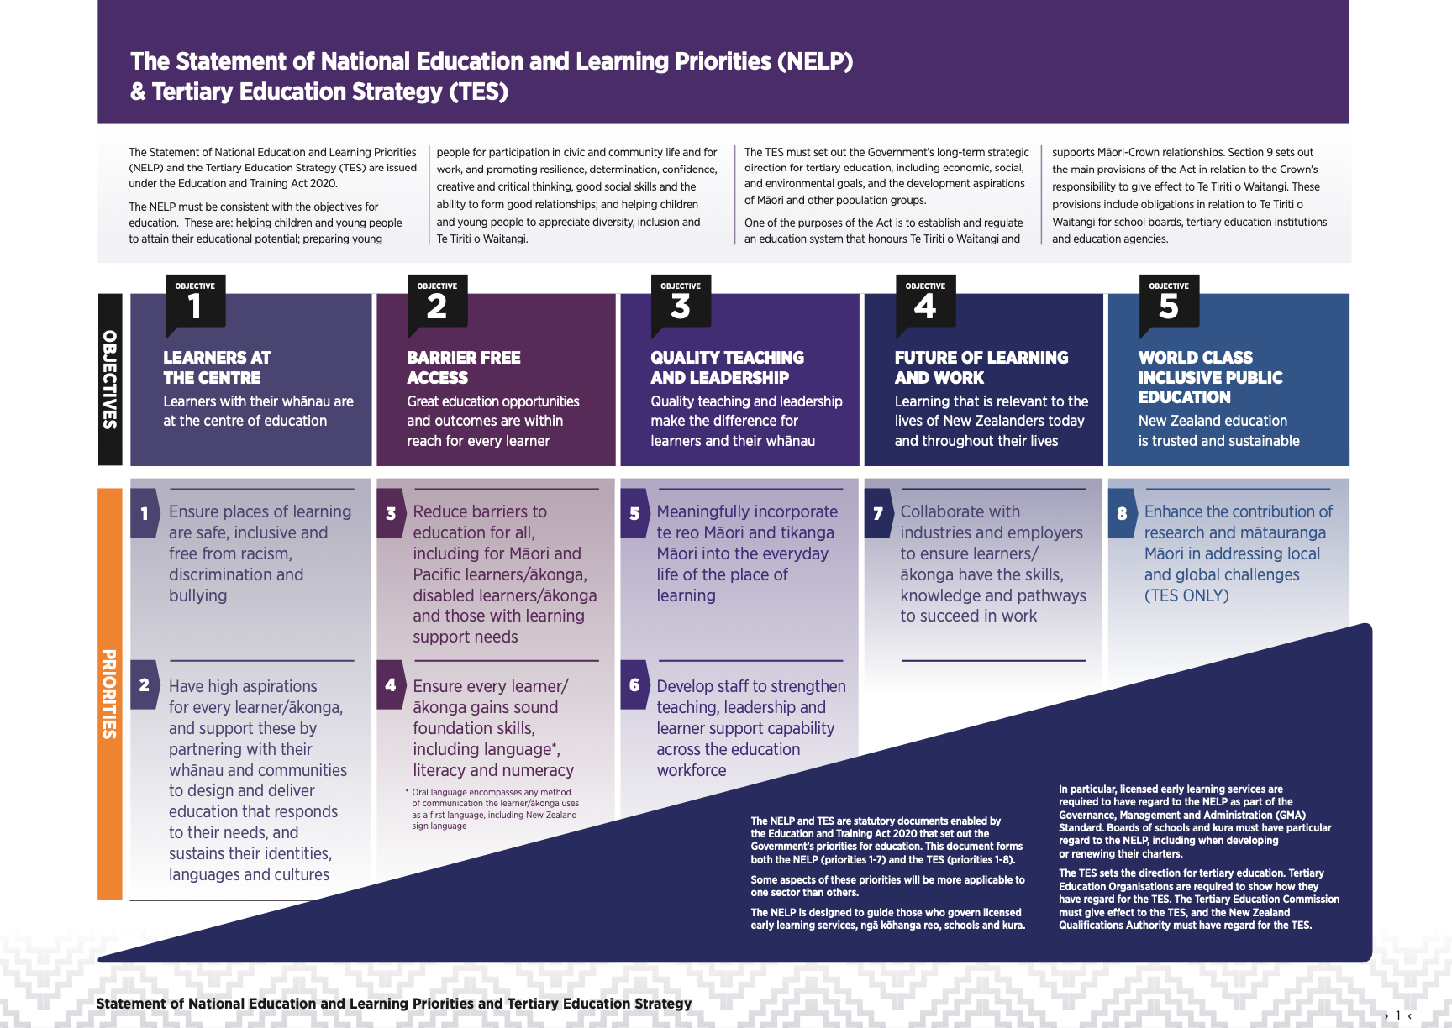
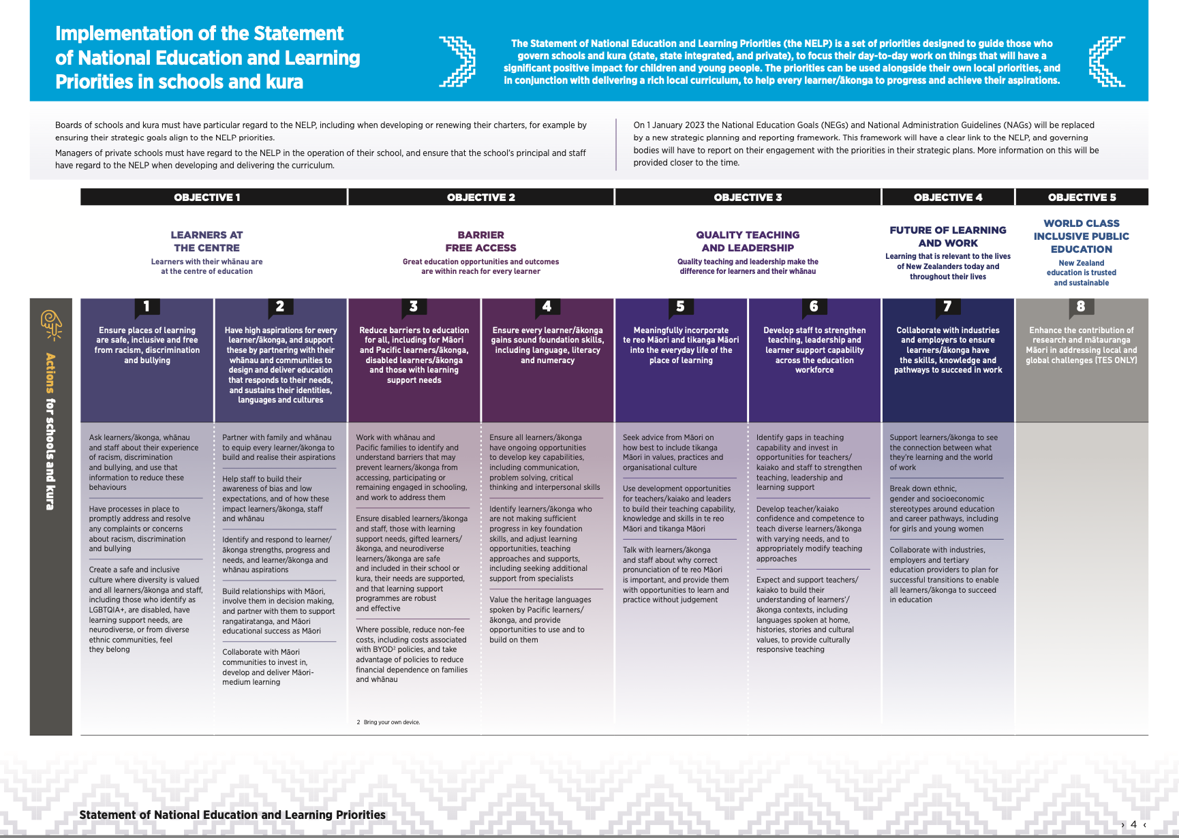
Targets
To maintain and monitor the achievement levels of all children based on historical achievement from the N/S era from 2014 until 2017 from targeted actions. We also place children who were below in the N/S era as within the curriculum level we would expect them to be in as there’s quite a lot of variance in where a child is achieving given there is variance in starting points and ages of children within year groups. The tolerance of curriculum levels is much more suitable in capturing natural variance in learning along with ages and stages.

Historical Position: Reading
2014 – 2017 Average (WB 18%) |  | Below – At or Above 82%
NZC2007 | 1 literacy progression level + below | Within one progression level or at or above normal curriculum level
2018 | 14% | 86%
2019 | 14% | 86%
2020 | 17% | 83%
2021 | 17% | 83%
2022 | 21% | 79%
2023 | 17% | Below: 23% AT: 48% AB:12%
2024 | 12% | Below: 13% AT: 69% AB: 6%
2025 | NS: 20% | PT: 21% P: 57% EX: 2%

Historical Position: Writing
2014 – 2017 Average (WB 24%) |  | Below – At or Above 76%
NZC2007 | 1 literacy progression level + below | Within one progression level or at or above normal curriculum level
2018 | 20% | 80%
2019 | 19% | 81%
2020 | 15% | 85%
2021 | 16.5% | 83.5%
2022 | 12% | 88%
2023 | 17% | Below: 16% AT: 60% AB:7%
2024 | 10% | Below: 22% AT: 63% AB: 5%
2025 | NS: 29% | PT: 27% P: 44% EX: 0%

Historical Position: Maths
2014 – 2017 Average (WB 18%) |  | Below – At or Above 82%
NZC2007 | 2 curriculum sub levels + below | Within, at or above normal curriculum level
2018 | 16% | 84%
2019 | 17% | 83%
2020 | 18% | 82%
2021 | 13% | 87%
2022 | 9% | 91%
2023 | 8% | Below: 26% AT: 58% AB: 9%
2024 | 11% | Below: 18% AT: 67% AB: 4%
2025 | NS: 24% | PT: 27% P: 48% EX: 1%

Our annual targets for specific children are effectively set through our Class Action Plans (CAPs). This is an adapted system established in 2022 to reduce double ups and administratively heavy assessment.

The results and analysis of the CAPs is generated into an annual report to establish the improvement and gains made for these children documented on the CAP.

